Assignment #4: Rotational Motion
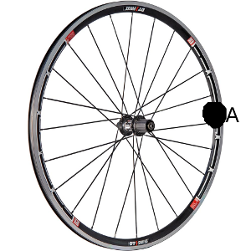
- You are looking at point A on the wheel. The wheel is rolling counterclockwise. It spins 8π radians in 2 seconds. Its radius is .3 m.
  - What is the arc-length (distance) that point a has traveled?

  - What is the rotational velocity of the wheel (speed and direction)?

  - What is the linear velocity of the wheel?

  - What is the time it would take the wheel to make 10 complete rotations?

  - How far does point A travel during that time? (Arc-length)

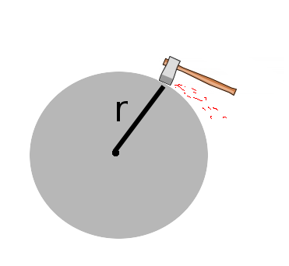
- Robert is sharpening his axe on a grinding stone. The radius of the stone is 0.25 meters. Initially, the wheel makes 3 rotations per second. After 20 seconds, the wheel comes to a complete stop.
  - What was the angular acceleration of the wheel?

  - How many rotations does the wheel make before coming to a complete stop?

  - What is the speed of the wheel (in radians per second) after 7.5 seconds?

  - What is the tangential velocity of the wheel at 17.3 seconds?

- A (rotational) trebuchet has a counterweight mounted a distance of 1.2 meters from the center of rotation. The length of the arm is 10 meters. When the trebuchet is fired, the counterweight accelerates at a rate of a = 4.5 m/s².
  - What is the angular acceleration of the trebuchet?

  - What is the time it will take the trebuchet to travel through an angle of 135º? (hint – convert to radians first).

  - What is the tangential acceleration of the arm?

  - What is the final angular velocity of the trebuchet after traveling through 135º?

  - What is the launch velocity of the projectile that is at the end of the arm?

  - Which of the following would make this trebuchet more efficient?

________ Increase the length of the arm.

________ Increase the distance to the counterweight.

________ Increase the mass of the projectile.

________ Increase the mass of the counterweight.

________ Increase the firing angle to 145 degrees.

